# Proposal Document

The goal of this project is an US University Finder for prospective students, firstly focused on International Student but is useful for citizen also.

The web app functionalities are filter and find universities based on important criteria:

Tuition cost, English test/GRE/GPA requirements, programs offered, availability of CPT Day One, inclusion in the MPOWER list, dependent cost, and more.

1. Login
   1. Will be possible to login in the application with user created.
   2. Will be able to use some functionalities without paying or having account.
2. FindbyTuitionCost Min or Max
   1. Will have a list of Tuition to be selected by the use and then filtered.
3. FindbyState
   1. Will have Possibility of selecting a State to filter.
4. FilterbyCourse
   1. When the grid with the universities result be filled the user is going to be able to filter by course. (This option will be available only if grid is filled)
5. FilterbyCPT1
   1. You will be able to filter by CPT day one universities
6. FilterbyCPT1 limit
   1. Will have a functionality that will check if the logged user is a premium user. If is not a premium user or the user is not logged the grid’s result will be limited to 3 universities.
7. DefaultGridResult
   1. Will have a functionality that will check if the logged user is a premium user. If is not a premium user or the user is not logged the grid’s result will be limited to 10 universities.
8. InMPowerList
   1. Will have a checkbox if you want to filter universities that are in Mpowerlist with the purpose of getting Loan.

**WireFrame**

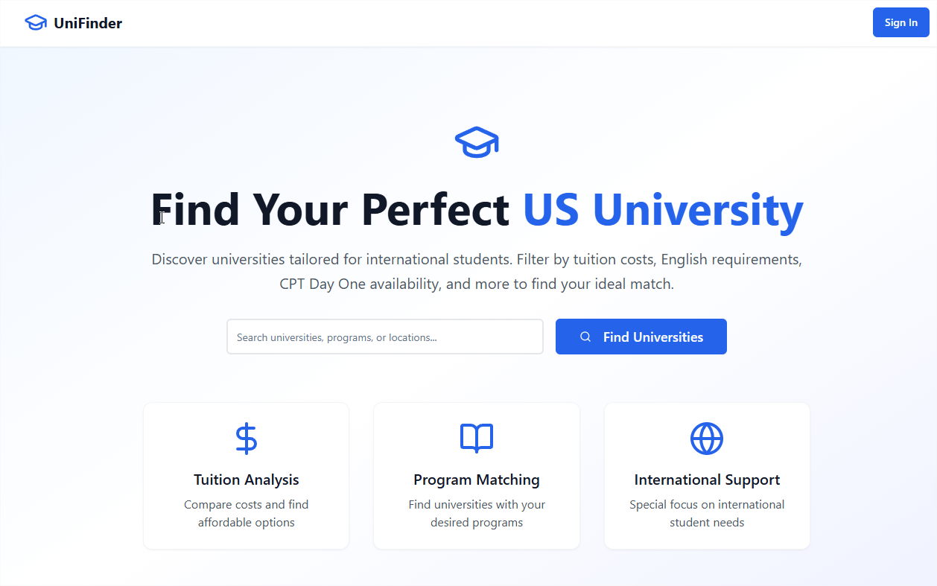  
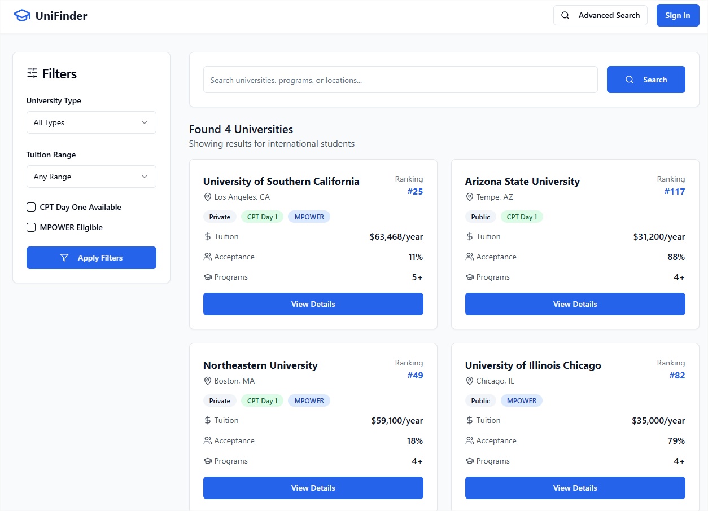

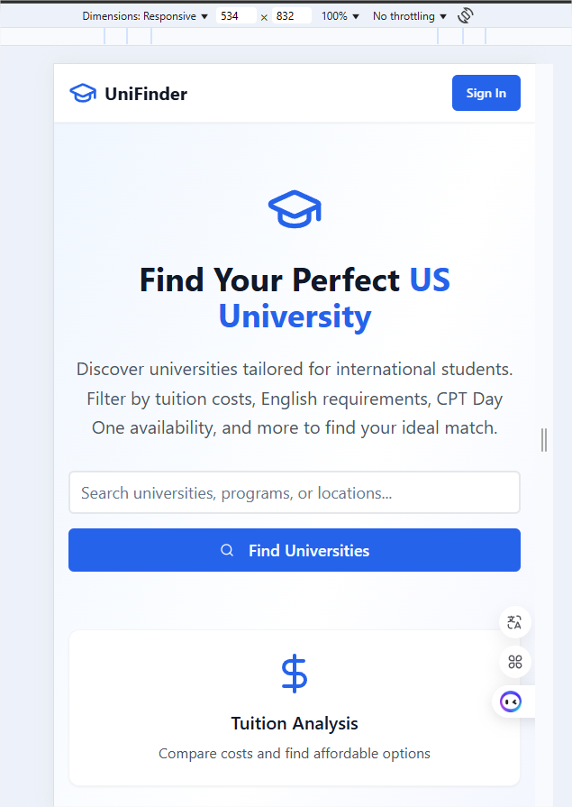

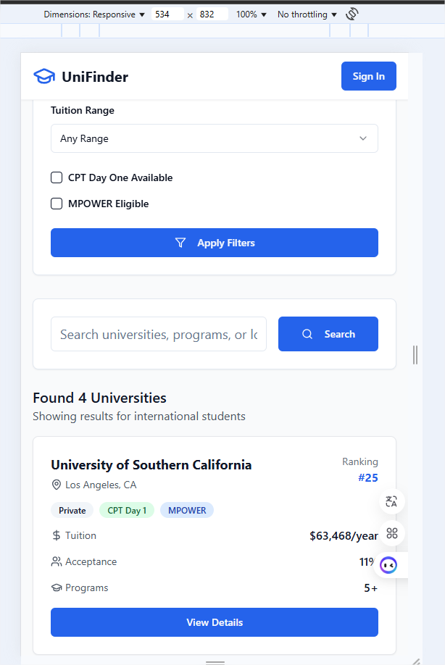

**External Data**

- ✅ [Google Firebase Authentication API] (https://firebase.google.com/products/auth) – for login with Google and Facebook

- ✅ [Razorpay/Stripe/PayPal API] (https://stripe.com/docs/api) – to manage paid user access

- ✅ [GeoDB Universities API] (https://rapidapi.com/wirefreethought/api/geodb-cities/) or [Universities API] (https://universities.hipolabs.com/) – to get basic university data

- ✅ [MPOWER List Integration via scraped CSV](https://developers.google.com/sheets/api) or Google Sheets API – if a public list is available

**Module**

* **Home –** main page with the details and presentation of the page.
* **Login –** Login page
* **SearchPage –** webpage with the grid, popup and form to search universities.

**Graphic**

Color Scheme

Primary Colors:

* Blue Primary: bg-blue-600 (#2563eb) and hover:bg-blue-700 (#1d4ed8)
* Blue Secondary: text-blue-600 for accents and links

Background Colors:

* Main Background: White background with shadow-sm border border-gray-100
* Primary Text: text-gray-900 (dark gray/black)
* Secondary Text: text-gray-600 (medium gray)
* Borders: border-gray-100, border-gray-200, border-gray-300

Typography

Font Family:

* System default font stack (Tailwind's default)

Font Sizes & Weights:

* Main Heading: text-4xl sm:text-6xl font-bold (large, responsive)
* Section Titles: text-xl font-semibold
* Card Titles: text-lg font-semibold
* Body Text: text-base and text-sm
* Button Text: text-lg font-semibold for primary buttons
* Labels: text-sm font-medium

Buttons:

* Primary: bg-blue-600 hover:bg-blue-700 text-white with padding px-8 py-2 or h-12
* Secondary: variant="outline" with gray borders

Cards:

* White background with shadow-sm border border-gray-100
* Hover effect: hover:shadow-md transition-shadow
* Rounded corners: rounded-xl for feature cards, rounded-md for others

**Timeline**

Until Saturday 31/01:

Start project structure

Develop and understand APIs to Use

Week 5:

Develop the HomePage

Start the LoginPage

Try integrate with Google

Week 6:

Develop the Search Page

Provide Listing functionality and filter aspects

Week 7:

Correct bugs

Provide page Working, if got time try to include payment options.

Ainda falta

1. **Project Planning**: A link to a Trello board with all the tasks you can think of at this point defined as cards. Again be as detailed as possible here.
2. While you should strive for thoroughness in your initial planning, understand that your project Trello board a living document that will be continuously updated and refined. Don't aim for perfection at the outset, but rather focus on capturing the essential tasks and adapting as your project progresses.
3. **Challenges**: What do you anticipate being the biggest challenges in building this application?